Fourier Transform: A R Tutorial
João Neto | March 2013 | http://www.di.fc.ul.pt/~jpn/r/fourier/fourier.html
Main references:
- Better Explained’s Fourier Transform tutorial
- A DFT & FFT Tutorial

Complex Wave
It is known that two or more sine waves can transverse the same path at the same time without mutual interference. Given the complex wave it is possible to extract its components (how that can be done is another problem).
Here are two examples of sine waves:
xs <- seq(-2*pi,2*pi,pi/100)
wave.1 <- sin(3*xs)
wave.2 <- sin(10*xs)
par(mfrow = c(1, 2))
plot(xs,wave.1,type="l",ylim=c(-1,1)); abline(h=0,lty=3)
plot(xs,wave.2,type="l",ylim=c(-1,1)); abline(h=0,lty=3)
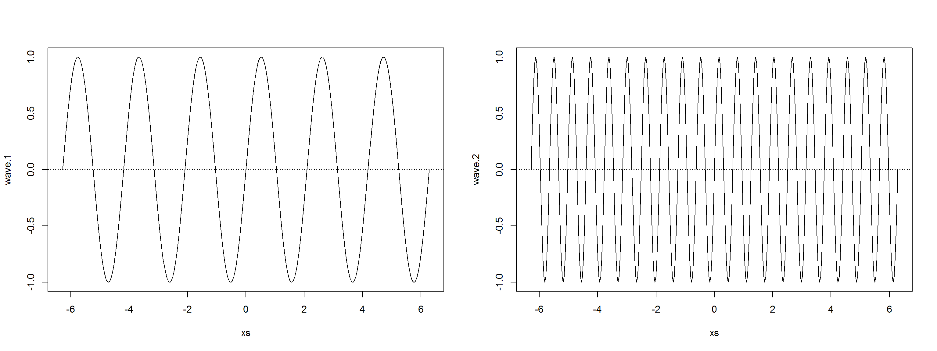
which can be linearly combined into a complex wave:
wave.3 <- 0.5 * wave.1 + 0.25 * wave.2
plot(xs,wave.3,type="l"); title("Eg complex wave"); abline(h=0,lty=3)
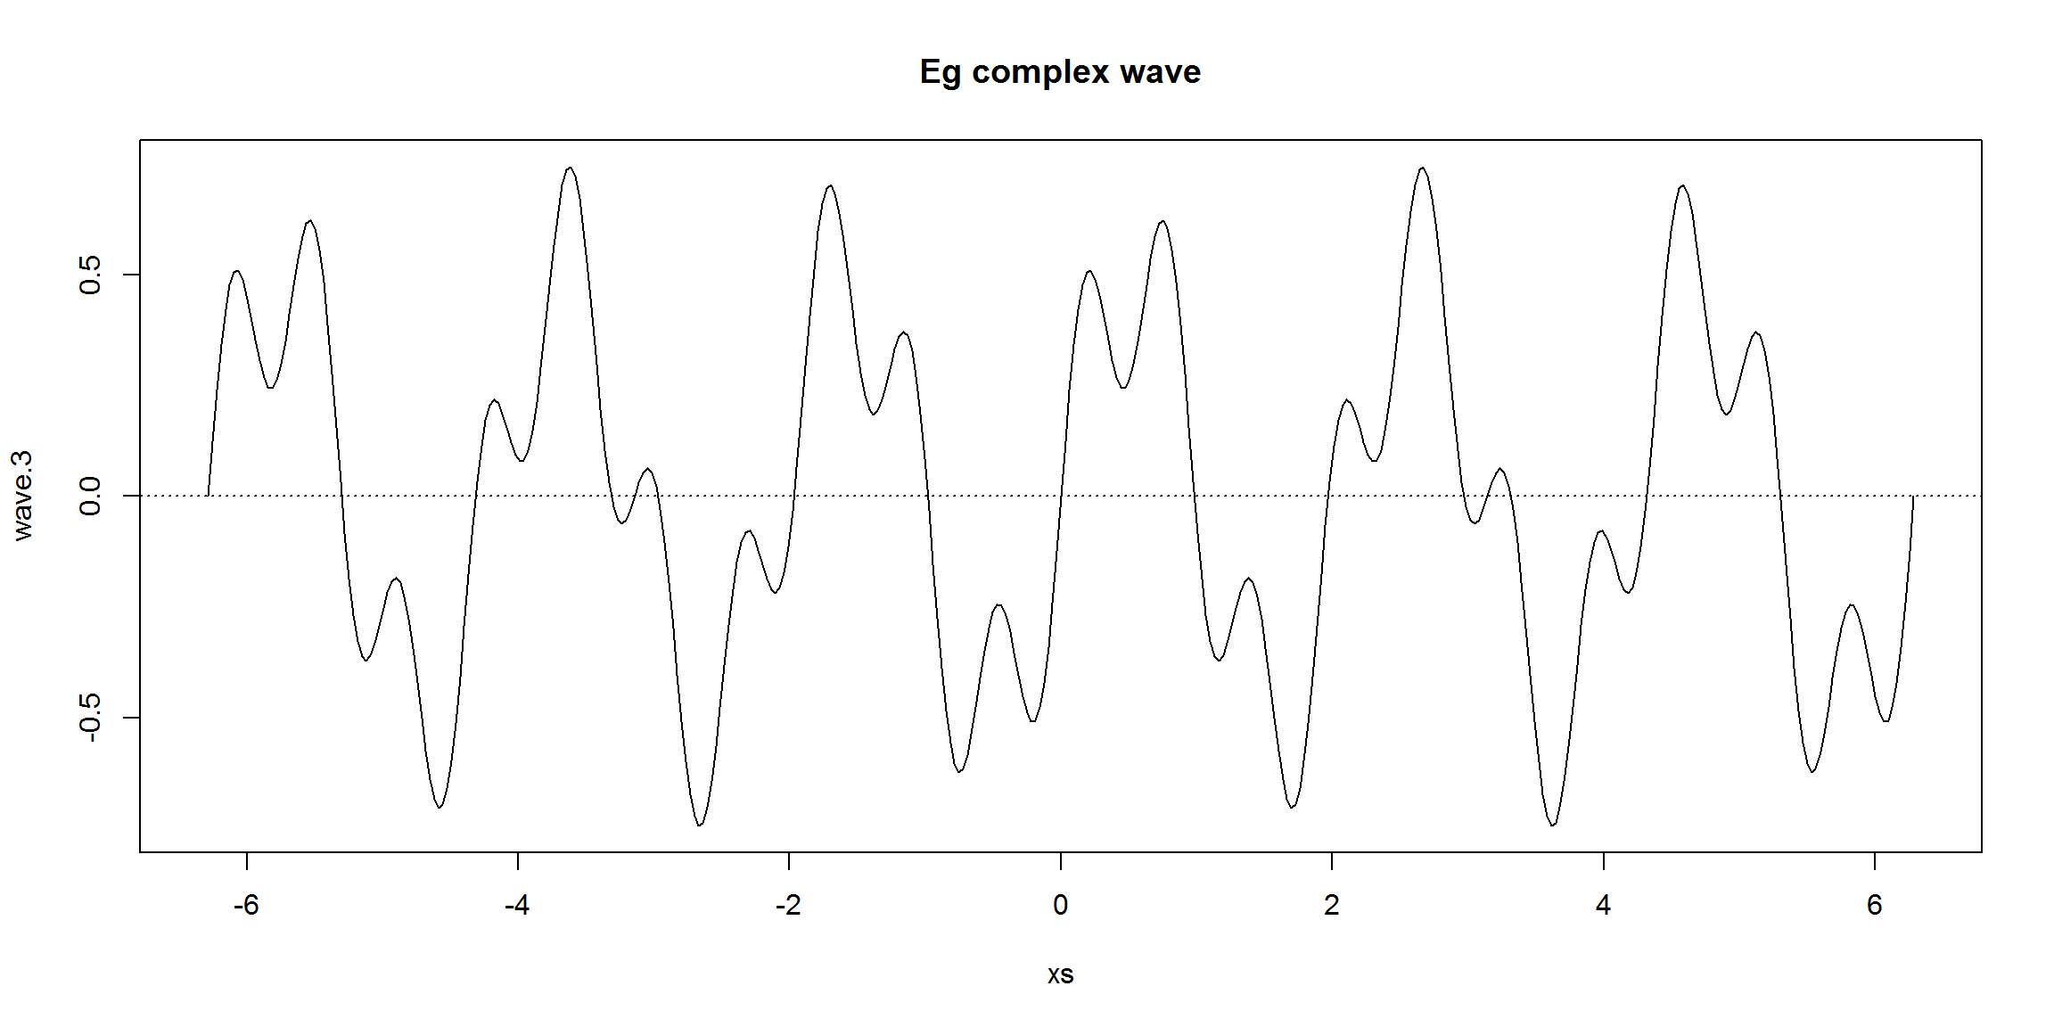

Fourier Series
Joseph Fourier showed that any periodic wave can be represented by a sum of simple sine waves. This sum is called the Fourier Series. The Fourier Series only holds while the system is linear. If there is, eg, some overflow effect (a threshold where the output remains the same no matter how much input is given), a non-linear effect enters the picture, breaking the sinusoidal wave and the superposition principle.
wave.4 <- wave.3
wave.4[wave.3>0.5] <- 0.5
plot(xs, wave.4, type="l", ylim=c(-1.25,1.25));
title("overflowed, non-linear complex wave"); abline(h=0,lty=3)
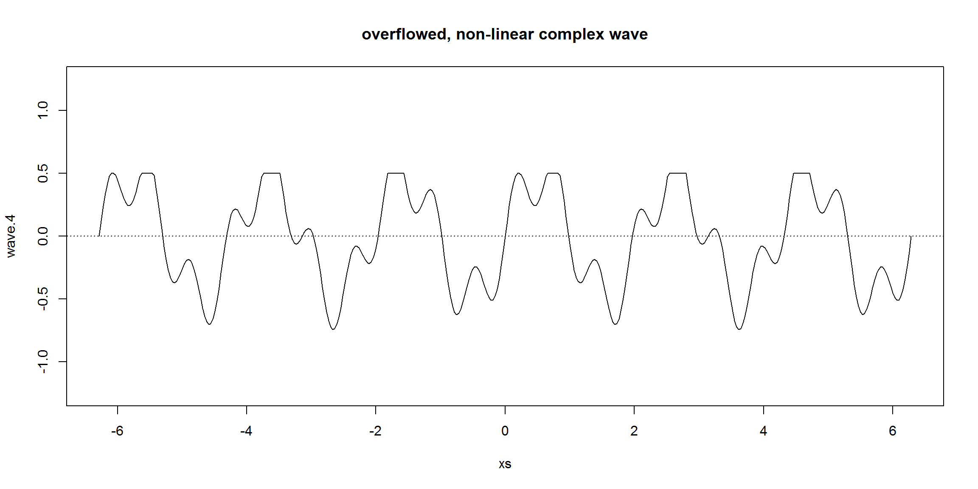
Also, the Fourier Series only holds if the waves are periodic, ie, they have a repeating pattern (non periodic waves are dealt by the Fourier Transform, see below). A periodic wave has a frequency ff and a wavelength λλ (a wavelength is the distance in the medium between the beginning and end of a cycle, λ=v/f0λ=v/f0, where vv is the wave velocity) that are defined by the repeating pattern. A non-periodic wave does not have a frequency or wavelength.
Some concepts:
- The fundamental period, T, is the period of all the samples taken, the time between the first sample and the last
- The sampling rate, sr, is the number of samples taken over a time period (aka acquisition frequency). For simplicity we will make the time interval between samples equal. This time interval is called the sample interval, si, which is the fundamental period time divided by the number of samples NN. So, si=TNsi=TN
- The fundamental frequency, f0f0, which is 1T1T. The fundamental frequency is the frequency of the repeating pattern or how long the wavelength is. In the previous waves, the fundamental frequency was 12π12π. The frequencies of the wave components must be integer multiples of the fundamental frequency. f0f0 is called the first harmonic, the second harmonic is 2∗f02∗f0, the third is 3∗f03∗f0, etc.

repeat.xs <- seq(-2*pi,0,pi/100)
wave.3.repeat <- 0.5*sin(3*repeat.xs) + 0.25*sin(10*repeat.xs)
plot(xs,wave.3,type="l"); title("Repeating pattern")
points(repeat.xs,wave.3.repeat,type="l",col="red"); abline(h=0,v=c(-2*pi,0),lty=3)
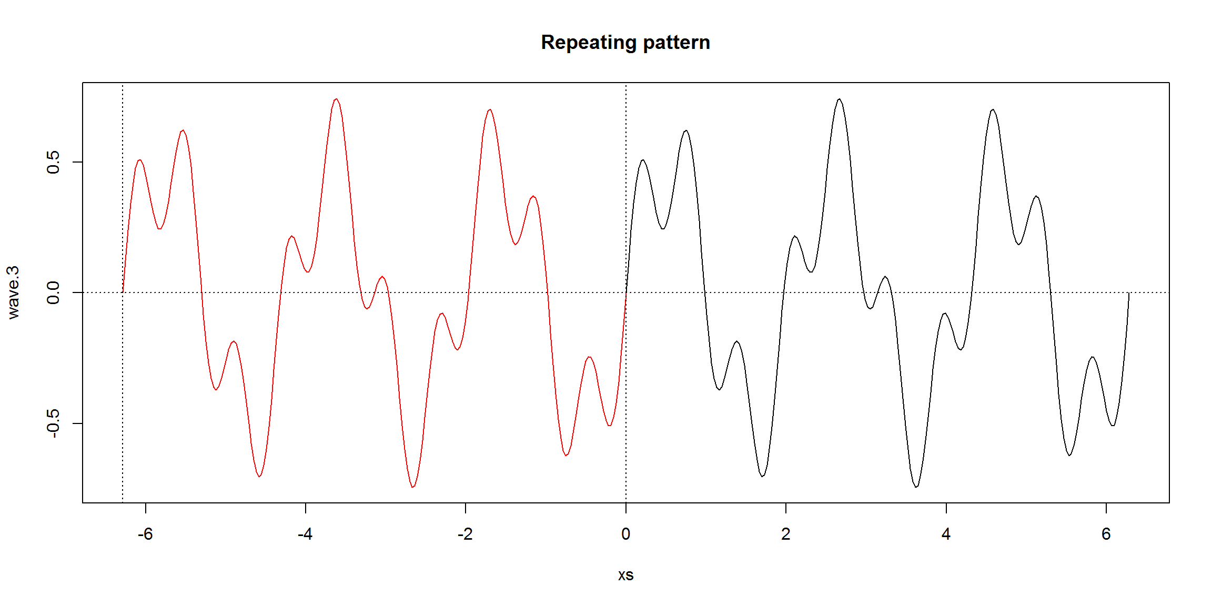
wave.3 is the weighted sum of wave.1 and wave.2. This equation is the Fourier Series for wave.3:
f(t)=0.5×sin(3wt)+0.25×sin(10wt)f(t)=0.5×sin(3wt)+0.25×sin(10wt)
where ww is the angular frequency (aka angular speed) in radians/second, w=2πf0w=2πf0, where f0f0 is the fundamental frequency of the complex wave. In this case, the first component (wave.1) has thrice the frequency and the second component has 10 times that of f0f0.
Here’s a R function for plotting trajectories given a fourier series:
plot.fourier <- function(fourier.series, f.0, ts) {
w <- 2*pi*f.0
trajectory <- sapply(ts, function(t) fourier.series(t,w))
plot(ts, trajectory, type="l", xlab="time", ylab="f(t)"); abline(h=0,lty=3)
}
# An eg
plot.fourier(function(t,w) {sin(w*t)}, 1, ts=seq(0,1,1/100))
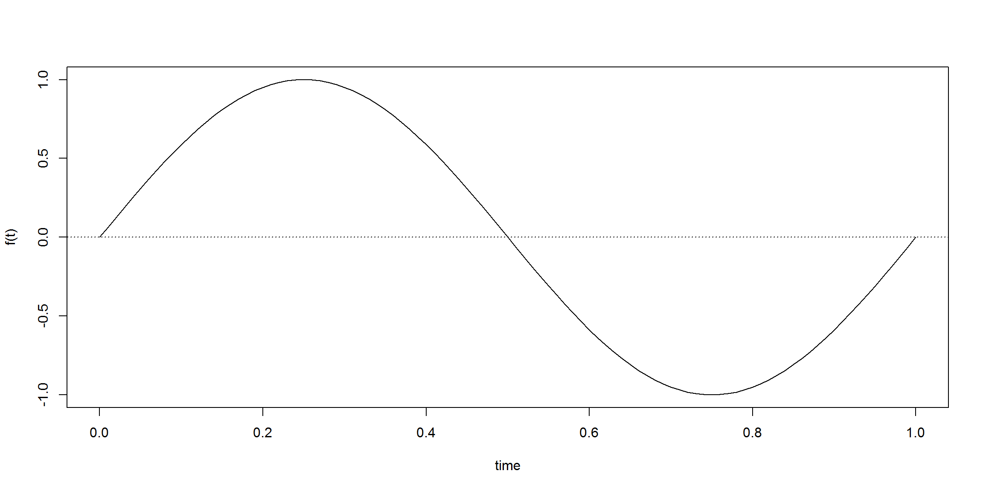
And the plotting of equation f(t)=0.5×sin(3wt)+0.25×sin(10wt)f(t)=0.5×sin(3wt)+0.25×sin(10wt):
acq.freq <- 100 # data acquisition frequency (Hz)
time <- 6 # measuring time interval (seconds)
ts <- seq(0,time,1/acq.freq) # vector of sampling time-points (s)
f.0 <- 1/time # fundamental frequency (Hz)
dc.component <- 0
component.freqs <- c(3,10) # frequency of signal components (Hz)
component.delay <- c(0,0) # delay of signal components (radians)
component.strength <- c(.5,.25) # strength of signal components
f <- function(t,w) {
dc.component +
sum( component.strength * sin(component.freqs*w*t + component.delay))
}
plot.fourier(f,f.0,ts)
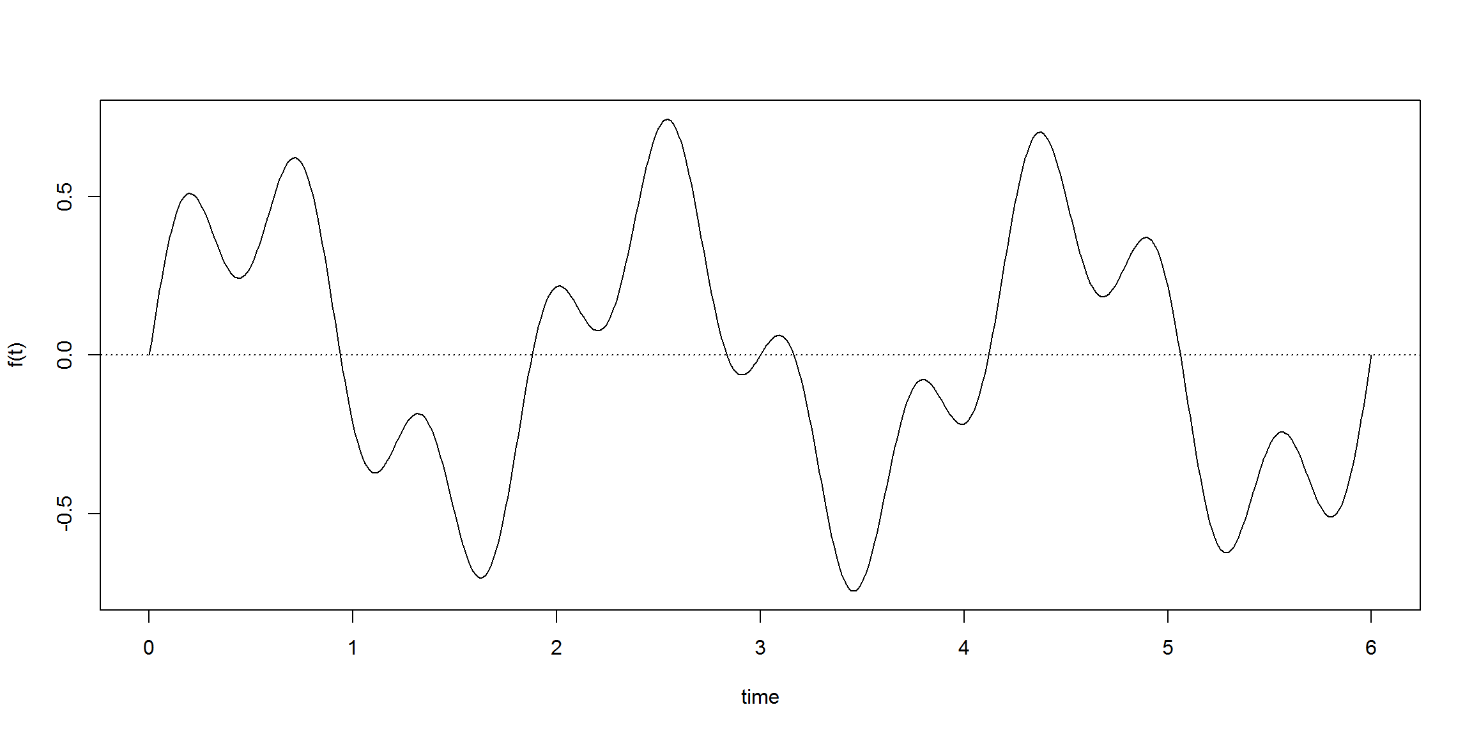

Phase Shifts
Another feature of the fourier series is phase shift. Phase shifts are translations in the x-axis for a given wave component. These shifts are measured in angles (radians).
Taking the previous example and shifting wave.1 by π2π2 we would produce the following fourier series:
f(t)=0.5×sin(3wt+π2)+0.25×sin(10wt)f(t)=0.5×sin(3wt+π2)+0.25×sin(10wt)
which produces the following trajectory:
component.delay <- c(pi/2,0) # delay of signal components (radians)
plot.fourier(f,f.0,ts)
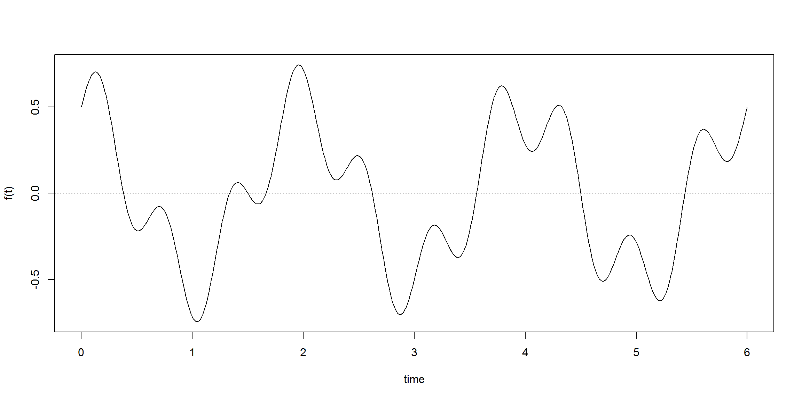

DC Components
This concept deals with translations over the y-axis. In this case corresponds to an additive constant signal.
Applying a DC component of −2−2 to the previous ware would result in the following equation and plot:
f(t)=−2+0.5×sin(3wt+π2)+0.25×sin(10wt)f(t)=−2+0.5×sin(3wt+π2)+0.25×sin(10wt)
dc.component <- -2
plot.fourier(f,f.0,ts)
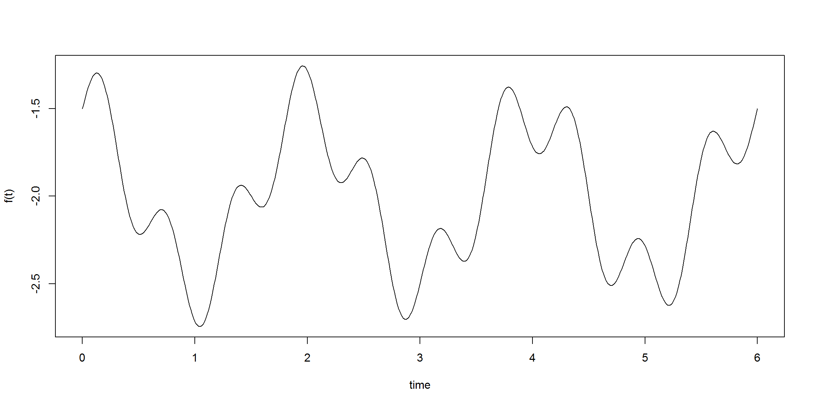

The General Equation
Adding these concepts we get the general form of the Fourier Series:
f(t)=a0+∑kak×sin(kwt+ρk)f(t)=a0+∑kak×sin(kwt+ρk)
where a0a0 is the DC component, w=2πf0w=2πf0, where f0f0 is the fundamental frequency of the original wave.
Each wave component ak×sin(kwt+ρk)ak×sin(kwt+ρk) is also called a harmonic.
There is also an alternative representation using the identity:
sin(a+b)=sin(a)cos(b)+cos(a)sin(b)sin(a+b)=sin(a)cos(b)+cos(a)sin(b)
which allow us to replace phase shifts with cosines.
The Fourier Transform (FT) is a generalization to solve for non-periodic waves. The FT assumes that the finite analyzed segment corresponds to one period of an infinitely extended periodic signal.

Fourier Transform
The Fourier Transform sees every trajectory (aka time signal, aka signal) as a set of circular motions.
Given a trajectory the fourier transform (FT) breaks it into a set of related cycles that describes it. Each cycle has a strength, a delay and a speed. These cycles are easier to handle, ie, compare, modify, simplify, and if needed, they can be used to reconstruct the original trajectory.
The trajectory is processed thru a set of filters:
- each filter gives us a cycle and the remainder of the trajectory
- filters are independent, each one catches a different part of the trajectory
- there are enough filters to catch all of the trajectory, ie, the last filter leaves no trajectory remainder
The result cycles can be combined linearly, giving the same results no matter the mixing order.
So, the FT algorithm receives a trajectory, apply its filters to find the appropriate cycles, and outputs the full set of cyclic components. There are two algorithms:
- the Discrete Fourier Transform (DFT) which requires O(n2)O(n2) operations (for nn samples)
- the Fast Fourier Transform (FFT) which requires O(n.log(n))O(n.log(n)) operations
This tutorial does not focus on the algorithms. There’s a R function called fft() that computes the FFT.
Here are two egs of use, a stationary and an increasing trajectory:
library(stats)
fft(c(1,1,1,1)) / 4 # to normalize
## [1] 1+0i 0+0i 0+0i 0+0i
fft(1:4) / 4
## [1] 2.5+0.0i -0.5+0.5i -0.5+0.0i -0.5-0.5i
Soon we will be able to interpret these results :-)
First we need to recapitulate one particular mathematical point.

Geometric Interpretation of Complex Numbers
Here’s a Geogebra applet to explain how we can interpret geometrically expressions like z×ediz×edi. Please try until you understand it:

So when moving:
- the d slider makes the point moving in circles
- the z slider makes the circular wider or narrower
This makes expressions like z×ediz×edi very good candidates to express circular motions.
To learn about using complex numbers in R check www.johnmyleswhite.com/notebook/2009/12/18/using-complex-numbers-in-r/
note: With this interpretation the great Euler’s formula, eπi=−1eπi=−1, can be understood: it means a 180 degrees (ππ radians) rotation, placing the point in the x-axis, in the opposite side of the unit circle, ie, at point (-1,0) in the complex plane, which is the integer −1−1.

Cycle’s properties
We mentioned that each cycle has a strength, a delay and a speed. How can we represent them?
- The strength is represented by the circle size, which is controlled by zz
- The delay, or starting point, is given by an initial value of dd
- The speed will be represented by the rate of change of dd over time
Here’s an animation taken shamelessly from Better Explained describing a circular path:

Fiddle in the Cycles/Time textboxes to see what happens.
Anyway, remember this output?
fft(1:4) / 4 # to normalize
## [1] 2.5+0.0i -0.5+0.5i -0.5+0.0i -0.5-0.5i
Here’s an animation for the same trajectory:

In the Cycles textbox the values after the colons mean the starting point of that cycle (in degrees), ie, the cycle’s delay. So :180 means that that cycle starts at the initial rotation of 180 degrees, or ππ radians.
The cycles shown here for the trajectory 1,2,3,4 is 2.5 0.71:135 0.5:180 0.71:-135 which is just another way to represent the output of the fft() R function. The fft() function returns a sequence complex numbers, while the animation returns pairs strength:delay (in degrees).
Here’s a little function to convert the fft() output to the animation output:
# cs is the vector of complex points to convert
convert.fft <- function(cs, sample.rate=1) {
cs <- cs / length(cs) # normalize

distance.center <- function(c)signif( Mod(c), 4)
angle <- function(c)signif( 180*Arg(c)/pi, 3)

df <- data.frame(cycle = 0:(length(cs)-1),
freq = 0:(length(cs)-1) * sample.rate / length(cs),
strength = sapply(cs, distance.center),
delay = sapply(cs, angle))
df
}

convert.fft(fft(1:4))
## cycle freq strength delay
## 1 0 0.00 2.5000 0
## 2 1 0.25 0.7071 135
## 3 2 0.50 0.5000 180
## 4 3 0.75 0.7071 -135
which is the output of the previous animation.
So this takes care of strength and delay. What about speed? That is given by the cycles’ sequence. The first cycle is stationary (0 Hz, ie, the DC component), then for every next cycle, the frequency increases (1Hz, 2Hz, 3Hz,…).
Try these cycle’s sequences in the animation:
- 1
- 0 1 this is the first animation
- 0 0 1
- and so on, until you understand the pattern…
A cycle sequence with just one 1 in the i-th position means a pure cycle of (i+1) Hz, ie, it completes i+1 cycles per time interval.
It’s also possible to combine! A sequence 1 2 3 means that the 0 Hz cycle has strength 1, the 1 Hz cycle has strength 2, and the 2 Hzcycle has strenght 3:

See how the biggest green vector at the left rotates faster? That one is the 2 Hz cycle that we gave the largest strength.
The yellow dots (or ticks) mean the equally spaced time intervals before the trajectory repeats itself. In this case there are 3 since we have cycles up to 2 Hz. At tick 0 the three cycles have a combine strength of 6 (1+2+3) since they all start at angle zero (no delays). At tick 1 their sum is -1.5 since both the 2nd and 3rd cycle make a negative contribution, which again happens at tick 2. After that, the trajectory restarts.
The blue line is the weighted sum of all the cycles’ values. Notice that the blue line also has values between the data points. Consider it as an interpolation, the values that this modeling suggests where the signal should be between two given data points. But the important part is that, at the required points, the function has the correct values.
With cycle set 1 2 3:180 we see that initially the 2 Hz cycle starts in the opposite side and so the combined strength of the first two cycles balance exactly the strength of the third cycle. That’s why the first trajectory number is zero.
Usually we want to know the inverse: what should the cycles be so that their combine strengths result on a given known trajectory? That is what DFT/FFT computes.
Say that we want values 4 0 0 0 in the time series (a peak every four units of time). We must have cycles that start initially with a sum of 4 and then cancel each other for the next 3 time steps. Use the animation to find what those cycles are. The solution is 1 1 1 1. That is, initially all four cycles contribute to the output, then at time t=1 the 2 Hz cycle cancels the 0 Hz cycle (the DC component) while both 1 Hz and 3 Hz are zero. For time t=2 see for yourself what cycles cancel each other. For the last three moments, there is a destructive interference between all four cycles (from 0 Hz to 3 Hz).

The Equations
A Fourier Transform converts a wave from the time domain into the frequency domain. There is a set of sine waves that, when sumed together, are equal to any given wave. These sine waves each have a frequency and amplitude. A plot of frequency versus strength (amplitude) on an x-y graph of these sine wave components is a frequency spectrum (we’ll see one briefly). Ie, the trajectory can be translated to a set of frequency spikes.
In equation terms:

meaning:
- amount of frequency in the signal; eachvalue is a complex number including strength (amplitude) and phase shift
- number of samples
- current sample,
- current frequency, between 0 Hz to N-1 Hz
- not necessary but it gives the actual sizes of the time spikes
- is the percent of the time we’ve gone through
- the speed in radians/second
- the backwards-moving circular path. This last three tell how far we’ve moved, for this speed and time.
The function fft() returns these .
An inverse Fourier Transform (IFT) converts the frequency domain components back into the original time wave. This is given by the next equation:

A function that returns an interpolated trajectory given . It is interpolated because the only data we know are the measures (eg: some points like (t=0,signal=4), (1,0), (2,0) and (3,0)). Everything else is given by the results from Fourier Series computed by fft().
To perform a IFT use fft(X.k, inverse=TRUE) / length(X.k).
Anyway, here’s a function that applies the previous equation, ie, makes the IFT:
# returns the x.n time series for a given time sequence (ts) and
# a vector with the amount of frequencies k in the signal (X.k)
get.trajectory <- function(X.k,ts,acq.freq) {
N <- length(ts)
i <- complex(real = 0, imaginary = 1)
x.n <- rep(0,N) # create vector to keep the trajectory
ks <- 0:(length(X.k)-1)
for(n in 0:(N-1)) { # compute each time point x_n based on freqs X.k
x.n[n+1] <- sum(X.k * exp(i*2*pi*ks*n/N)) / N
}
x.n * acq.freq
}
Here’s two useful functions:
- plot.frequency.spectrum() plot a frequency spectrum of a given XkXk
- plot.harmonic() plots the i-th harmonic on the current plot
plot.frequency.spectrum <- function(X.k, xlimits=c(0,length(X.k))) {
plot.data <- cbind(0:(length(X.k)-1), Mod(X.k))
# TODO: why this scaling is necessary?
plot.data[2:length(X.k),2] <- 2*plot.data[2:length(X.k),2]
plot(plot.data, t="h", lwd=2, main="",
xlab="Frequency (Hz)", ylab="Strength",
xlim=xlimits, ylim=c(0,max(Mod(plot.data[,2]))))
}
# Plot the i-th harmonic
# Xk: the frequencies computed by the Fft
# i: which harmonic
# ts: the sampling time points
# acq.freq: the acquisition rate
plot.harmonic <- function(Xk, i, ts, acq.freq, color="red") {
Xk.h <- rep(0,length(Xk))
Xk.h[i+1] <- Xk[i+1] # i-th harmonic
harmonic.trajectory <- get.trajectory(Xk.h, ts, acq.freq=acq.freq)
points(ts, harmonic.trajectory, type="l", col=color)
}
Let’s check that last eg. Notice that this plot is equal to the blue line in the animation:
X.k <- fft(c(4,0,0,0)) # get amount of each frequency k
time <- 4 # measuring time interval (seconds)
acq.freq <- 100 # data acquisition frequency (Hz)
ts <- seq(0,time-1/acq.freq,1/acq.freq) # vector of sampling time-points (s)
x.n <- get.trajectory(X.k,ts,acq.freq) # create time wave
plot(ts,x.n,type="l",ylim=c(-2,4),lwd=2)
abline(v=0:time,h=-2:4,lty=3); abline(h=0)
plot.harmonic(X.k,1,ts,acq.freq,"red")
plot.harmonic(X.k,2,ts,acq.freq,"green")
plot.harmonic(X.k,3,ts,acq.freq,"blue")
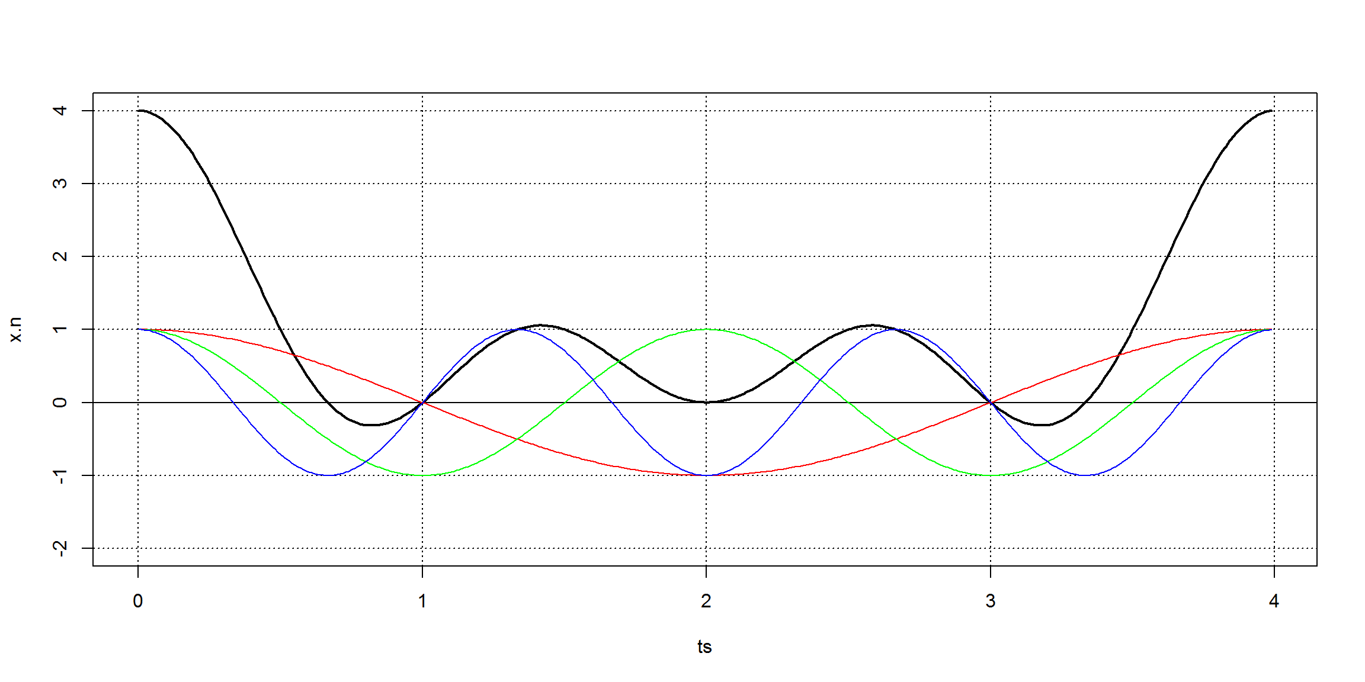
The result has lots of harmonics. Some of them are possibly the result of noise, and hopefully will be very weak. Usually, we will just need the strong harmonics: those that contribute meaningfully to the signal.
The highest meaningful sin wave frequency – after the fft-analysis of the original waveform signal – is at half the data acquisition frequency, because our input signal is composed of real values (ie, trajectory has no imaginary parts). The last useful bin is at acq.freq/2. The Nyquist Frequency is half the sampling rate. The Nyquist frequency is the maximum frequency that can be detected for a given sampling rate. This is because in order to measure a wave you need at least one trough and one peak to identify it.
One important point is that any signal can be described in two ways:
- a time domain, the x-axis is a time variable and the y-axis the signal’s amplitude
- a frequency domain, the x-axis is a frequency variable and the y-axis the signal’s amplitude
Sometimes it’s easier to deal with one description, sometimes with the other.
The DFT and the IFT are the mathematical tools that translate between these two descriptions.

Examples
Let’s try with one eg. We’ll make a trajectory given the following complex wave
f(t)=2+0.75×sin(3wt)+0.25×sin(7wt)+0.5×sin(10wt)f(t)=2+0.75×sin(3wt)+0.25×sin(7wt)+0.5×sin(10wt)
acq.freq <- 100 # data acquisition (sample) frequency (Hz)
time <- 6 # measuring time interval (seconds)
ts <- seq(0,time-1/acq.freq,1/acq.freq) # vector of sampling time-points (s)
f.0 <- 1/time
dc.component <- 1
component.freqs <- c(3,7,10) # frequency of signal components (Hz)
component.delay <- c(0,0,0) # delay of signal components (radians)
component.strength <- c(1.5,.5,.75) # strength of signal components
f <- function(t,w) {
dc.component +
sum( component.strength * sin(component.freqs*w*t + component.delay))
}
plot.fourier(f,f.0,ts=ts)
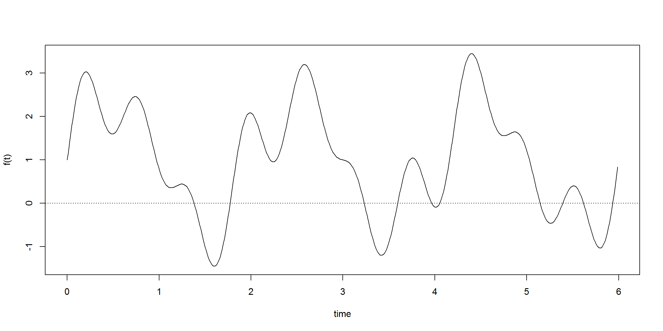
Let’s assume that we don’t know the functional form of trajectory, we only have its contents, the period and the sampling time points:
w <- 2*pi*f.0
trajectory <- sapply(ts, function(t) f(t,w))
head(trajectory,n=30)
## [1] 1.000000 1.162132 1.323161 1.481997 1.637568 1.788836 1.934801
## [8] 2.074515 2.207089 2.331703 2.447610 2.554146 2.650736 2.736896
## [15] 2.812242 2.876489 2.929454 2.971057 3.001324 3.020382 3.028458
## [22] 3.025877 3.013056 2.990502 2.958803 2.918623 2.870694 2.815807
## [29] 2.754805 2.688575
So, given that trajectory we can find where the frequency peaks are:
X.k <- fft(trajectory) # find all harmonics with fft()
plot.frequency.spectrum(X.k, xlimits=c(0,20))
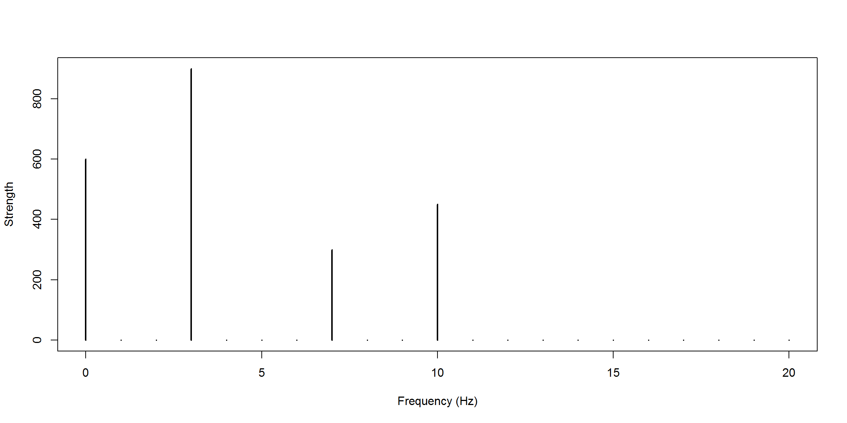
And if we only had the frequency peaks we could rebuild the signal:
x.n <- get.trajectory(X.k,ts,acq.freq) / acq.freq # TODO: why the scaling?
plot(ts,x.n, type="l"); abline(h=0,lty=3)
points(ts,trajectory,col="red",type="l") # compare with original
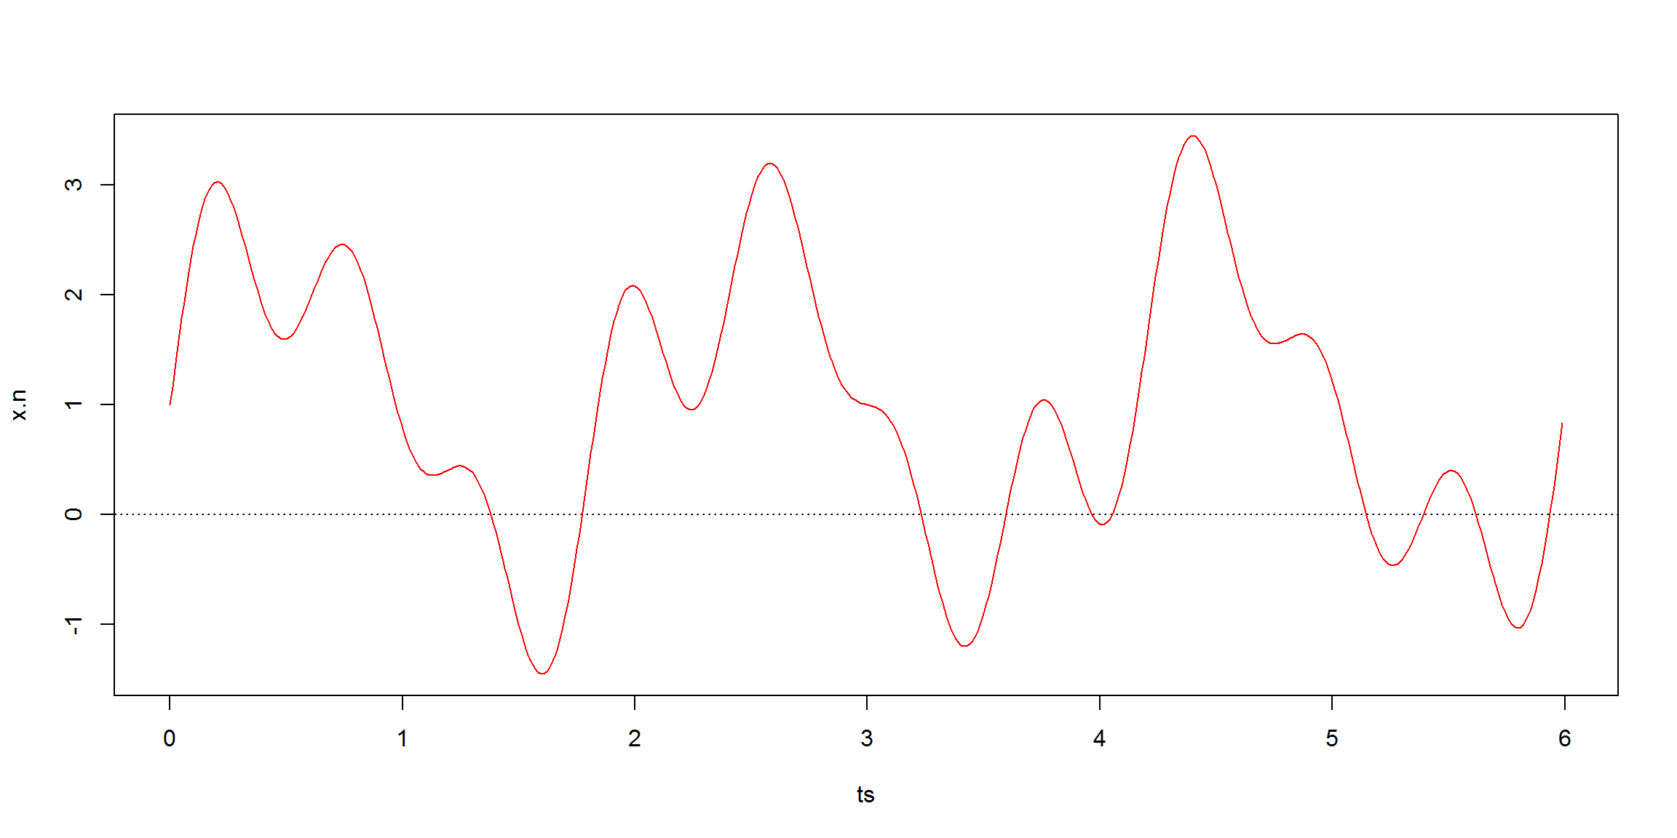
This function is just for presentation purposes:
plot.show <- function(trajectory, time=1, harmonics=-1, plot.freq=FALSE) {
acq.freq <- length(trajectory)/time # data acquisition frequency (Hz)
ts <- seq(0,time-1/acq.freq,1/acq.freq) # vector of sampling time-points (s)
X.k <- fft(trajectory)
x.n <- get.trajectory(X.k,ts, acq.freq=acq.freq) / acq.freq
if (plot.freq)
plot.frequency.spectrum(X.k)
max.y <- ceiling(1.5*max(Mod(x.n)))
if (harmonics[1]==-1) {
min.y <- floor(min(Mod(x.n)))-1
} else {
min.y <- ceiling(-1.5*max(Mod(x.n)))
}
plot(ts,x.n, type="l",ylim=c(min.y,max.y))
abline(h=min.y:max.y,v=0:time,lty=3)
points(ts,trajectory,pch=19,col="red") # the data points we know
if (harmonics[1]>-1) {
for(i in 0:length(harmonics)) {
plot.harmonic(X.k, harmonics[i], ts, acq.freq, color=i+1)
}
}
}
A decreasing signal:
trajectory <- 4:1
plot.show(trajectory, time=2)
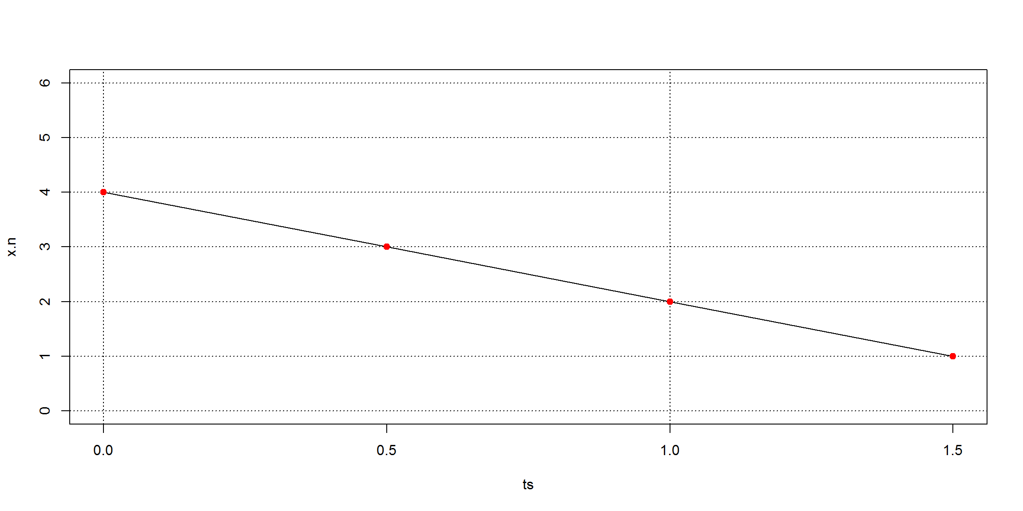
A staircase signal:
trajectory <- c(rep(1,5),rep(2,6),rep(3,7))
plot.show(trajectory, time=2, harmonics=0:3, plot.freq=TRUE)
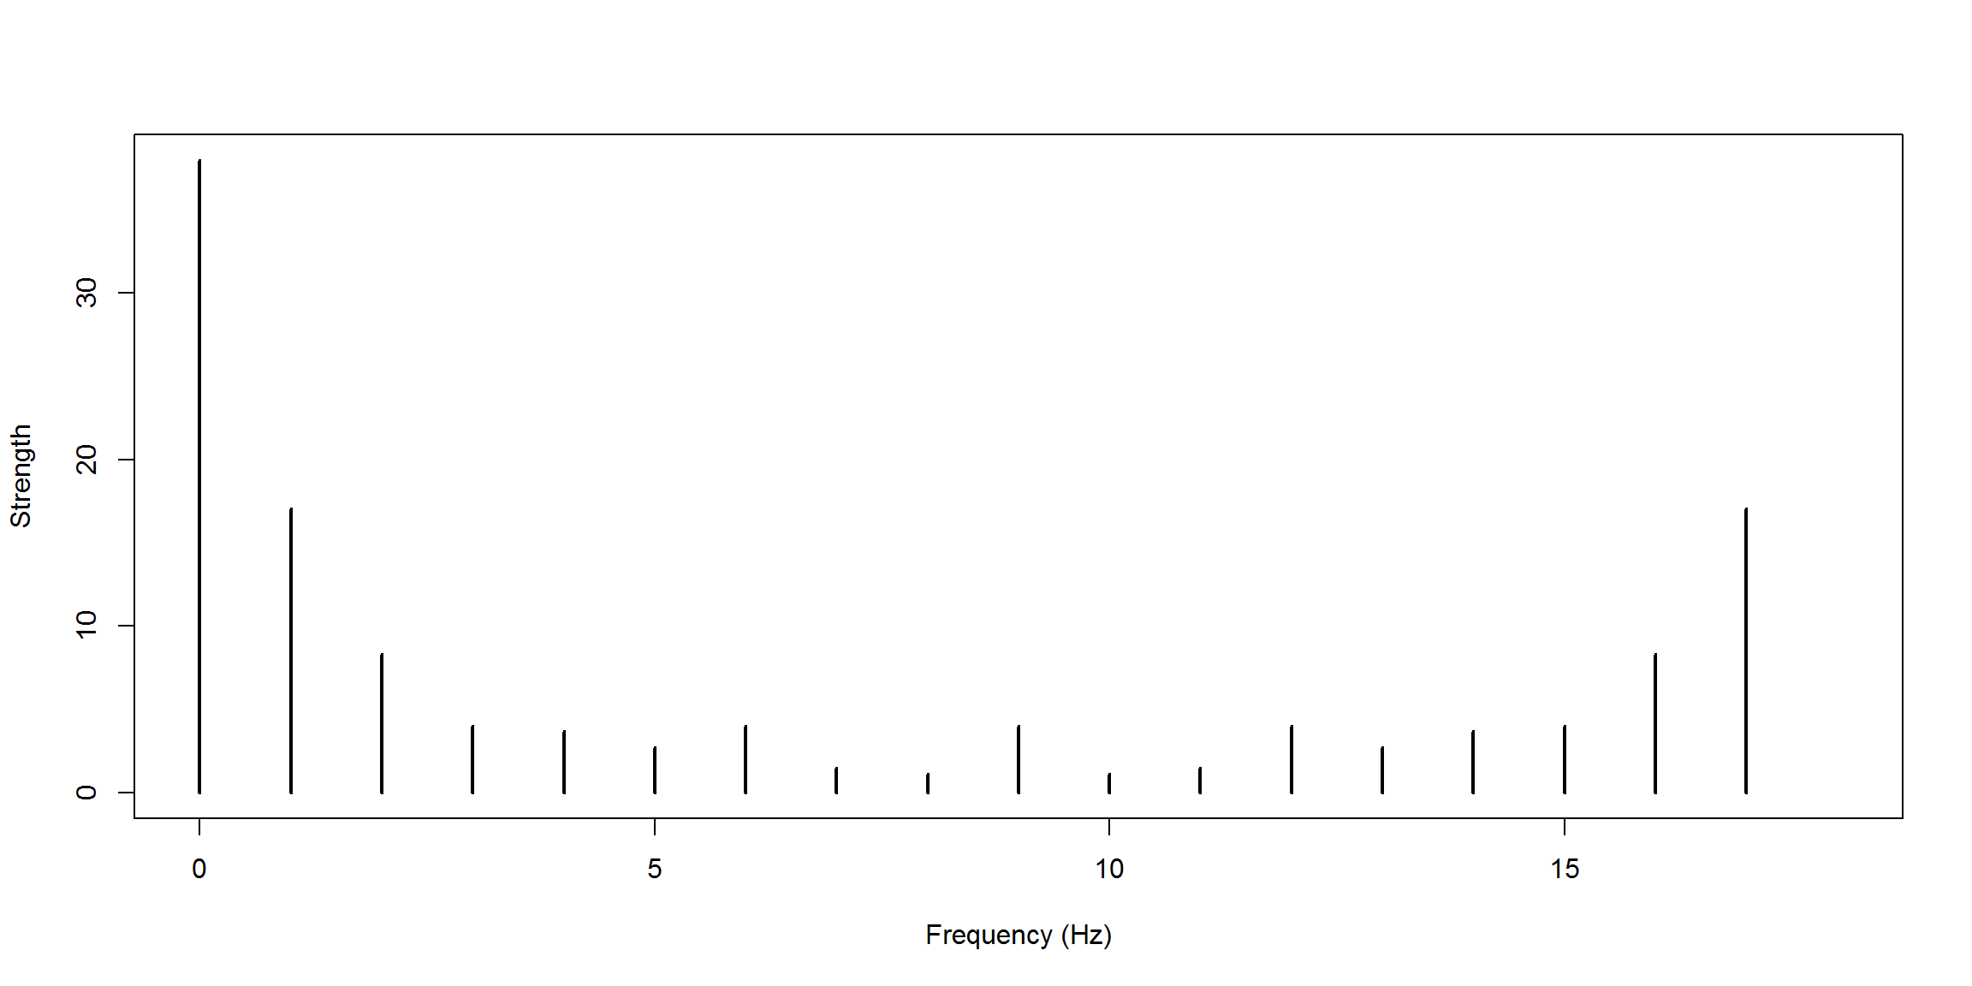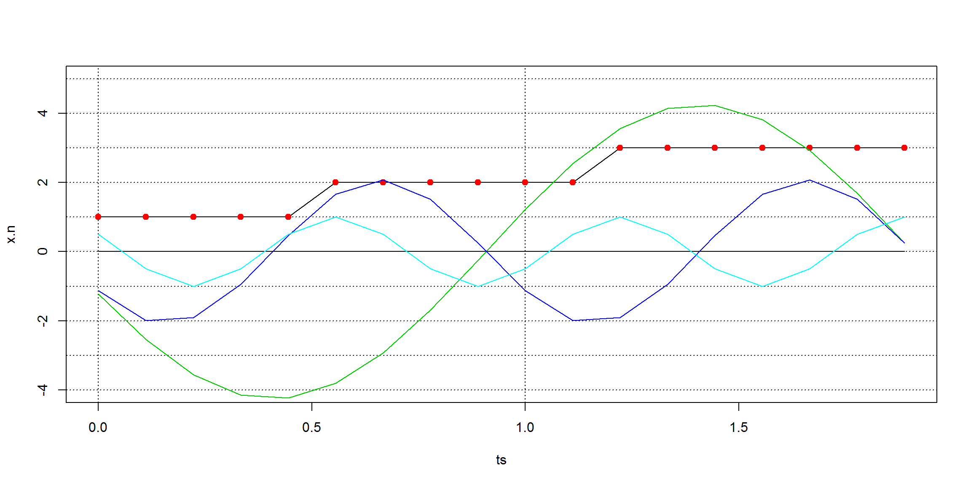
A seesaw:
trajectory <- c(1:5,2:6,3:7)
plot.show(trajectory, time=1, harmonics=c(1,2))
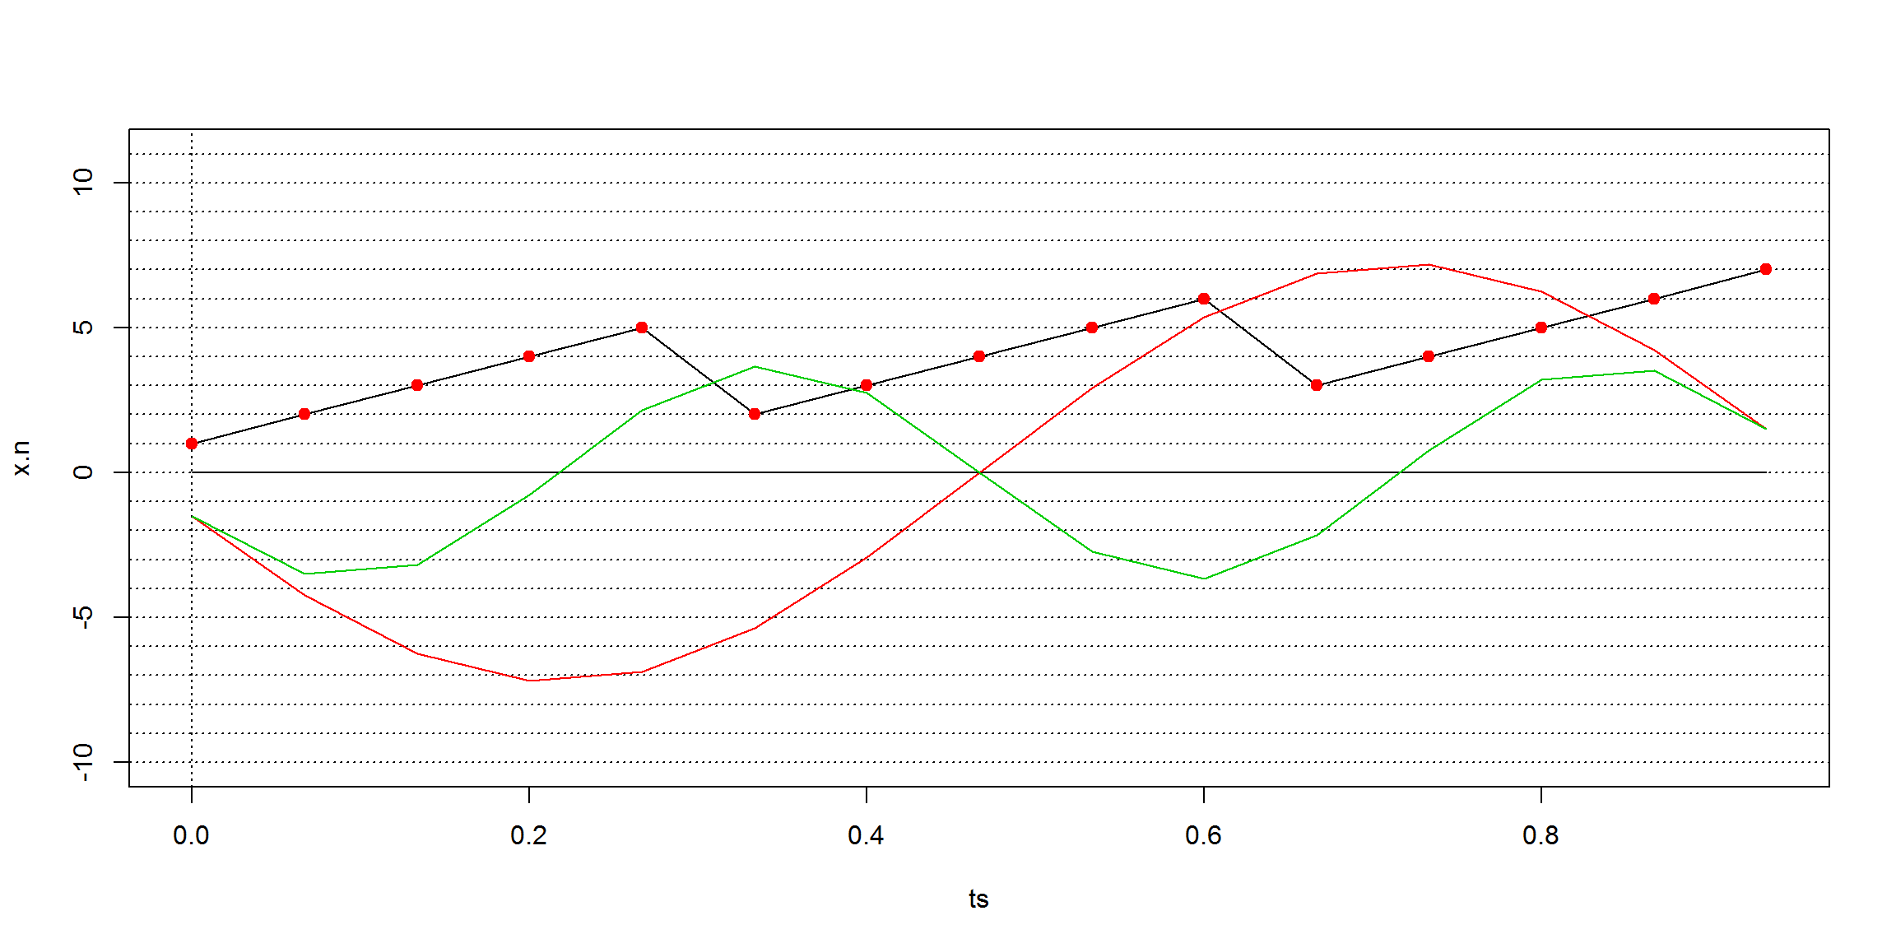
Assume this time-series with a strong noise component:
set.seed(101)
acq.freq <- 200
time <- 1
w <- 2*pi/time
ts <- seq(0,time,1/acq.freq)
trajectory <- 3*rnorm(101) + 3*sin(3*w*ts)
plot(trajectory, type="l")
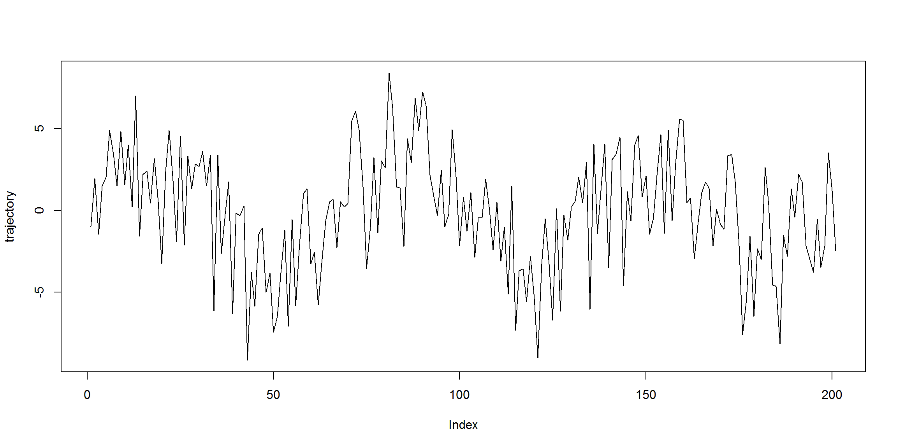
We can check if there’s some harmonic hidden in it (there is one, 3Hz harmonics):
X.k <- fft(trajectory)
plot.frequency.spectrum(X.k,xlimits=c(0,acq.freq/2))
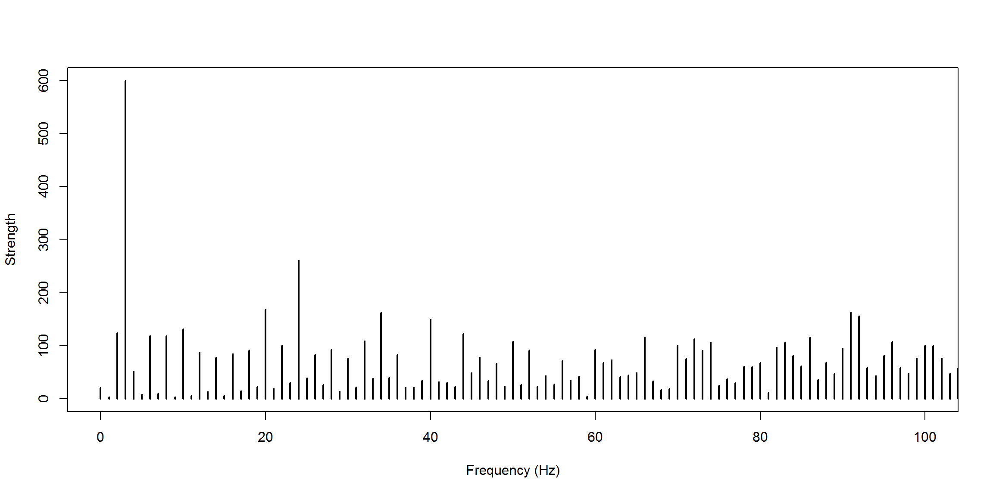
And we find a peak at the 3 Hz harmonics, as expected!
There are several R libraries (surprise!) that produce this type of frequency plots. Here’s one eg (the results are not exactly the same, which might be the consequence of slightly different algorithms…):
library(GeneCycle)
f.data <- GeneCycle::periodogram(trajectory)
harmonics <- 1:(acq.freq/2)
plot(f.data$freq[harmonics]*length(trajectory),
f.data$spec[harmonics]/sum(f.data$spec),
xlab="Harmonics (Hz)", ylab="Amplitute Density", type="h")
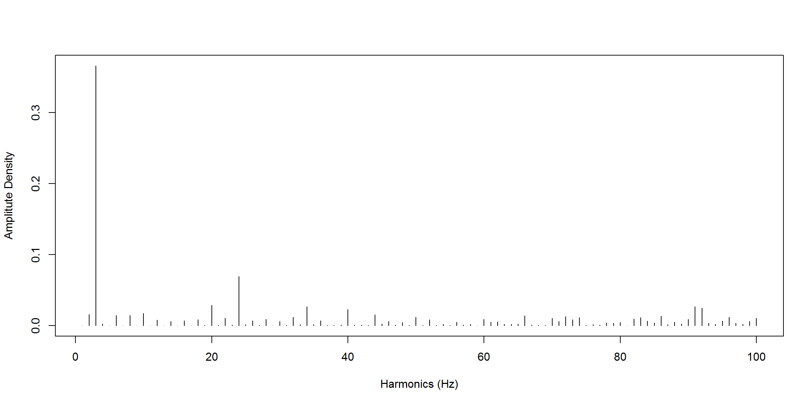
Check also stats::spectrum() and TSA::periodogram().
If there is a trend in the time series, it should be detrended.
Eg:
trajectory1 <- trajectory + 25*ts # let's create a linear trend
plot(trajectory1, type="l")
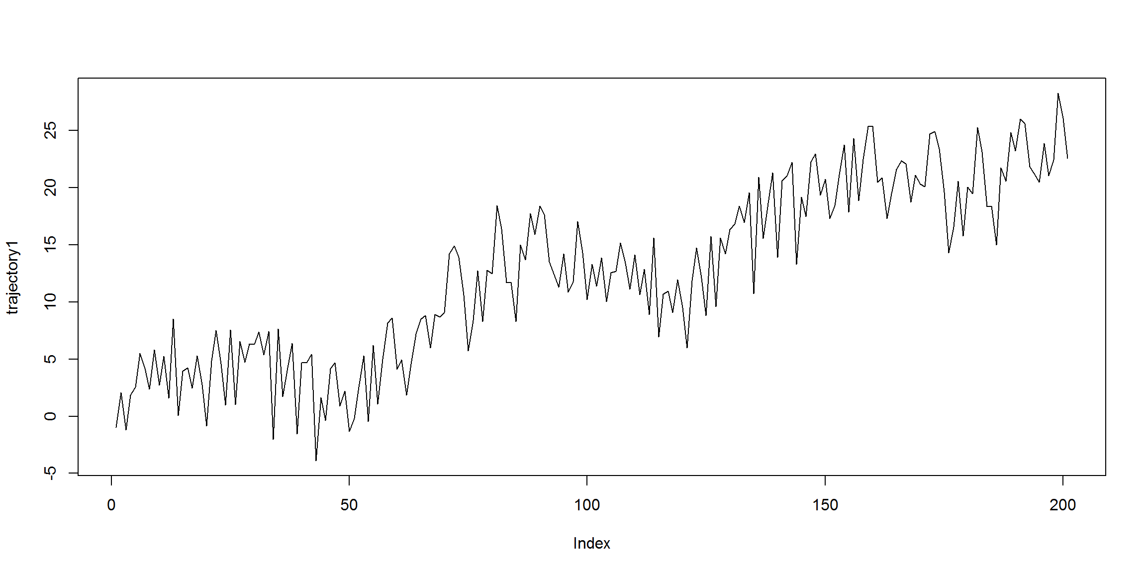
f.data <- GeneCycle::periodogram(trajectory1)
harmonics <- 1:20
plot(f.data$freq[harmonics]*length(trajectory1),
f.data$spec[harmonics]/sum(f.data$spec),
xlab="Harmonics (Hz)", ylab="Amplitute Density", type="h")
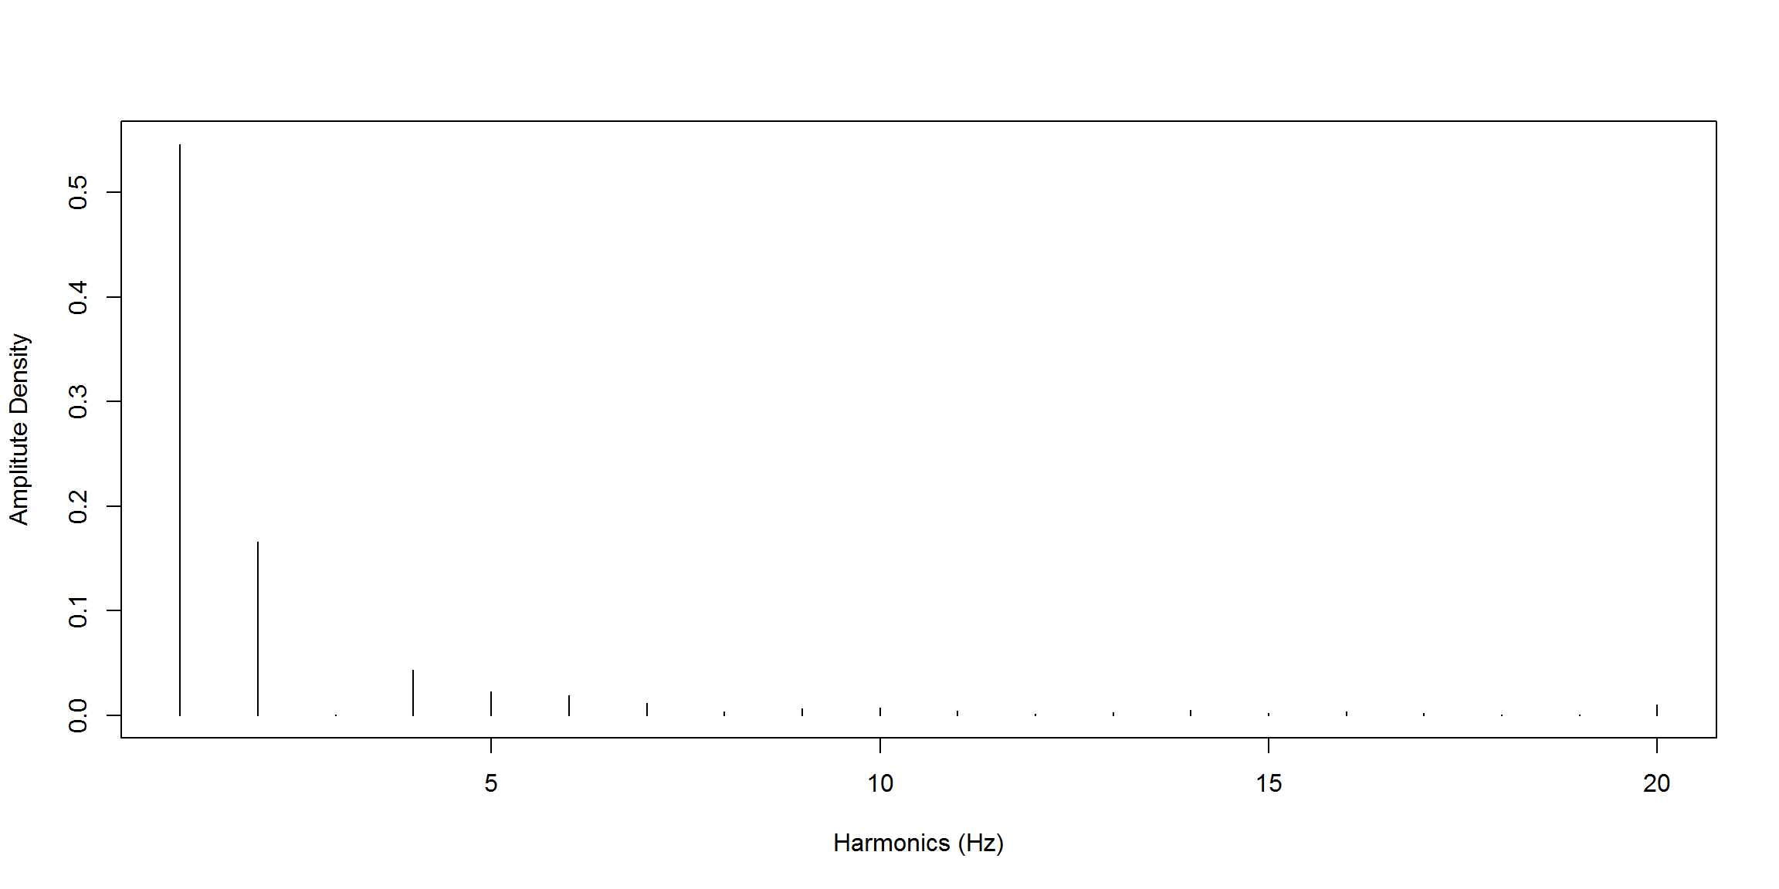
The trended time-series didn’t capture the signal.
Let’s detrended it know, ie, find the linear trend and work with the residuals:
trend <- lm(trajectory1 ~ts)
detrended.trajectory <- trend$residuals
plot(detrended.trajectory, type="l")
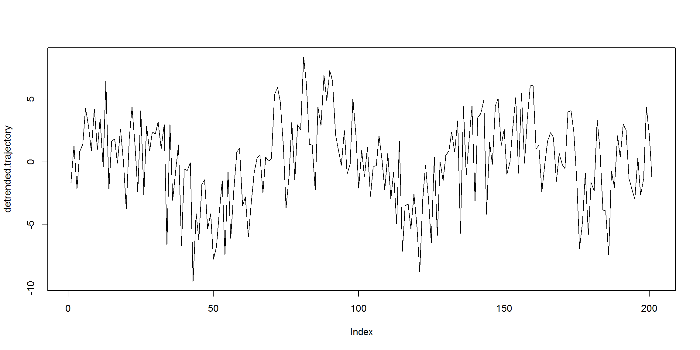
f.data <- GeneCycle::periodogram(detrended.trajectory)
harmonics <- 1:20
plot(f.data$freq[harmonics]*length(detrended.trajectory),
f.data$spec[harmonics]/sum(f.data$spec),
xlab="Harmonics (Hz)", ylab="Amplitute Density", type="h")
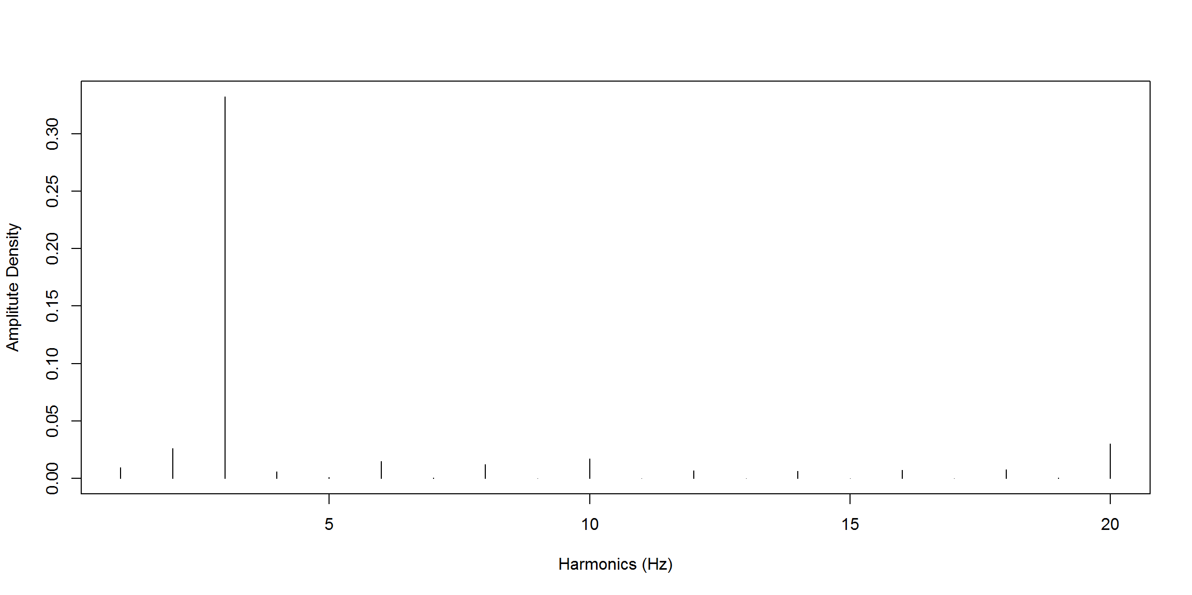
Now the signal was caught!
Also, if we are trying to identify signals of n×Fn×F Hz frequencies, the time series length should be divisible by FF, ie, we must do something like detrended.trajectory[-(1:(length(detrended.trajectory) %% F))].
Let’s try with a real dataset downloaded from Quandl from retail prices of gasoline from 1995 until the present.
library(zoo) # use: index() converts Date to its index
##
## Attaching package: 'zoo'
##
## The following objects are masked from 'package:base':
##
## as.Date, as.Date.numeric
prices <- read.csv("retailgas.csv") # weekly prices (1 Hz = 1 Week)
prices <- prices[order(nrow(prices):1),] # revert data frame
plot(prices, type="l")
trend <- lm(Price ~ index(Date), data = prices)
abline(trend, col="red")
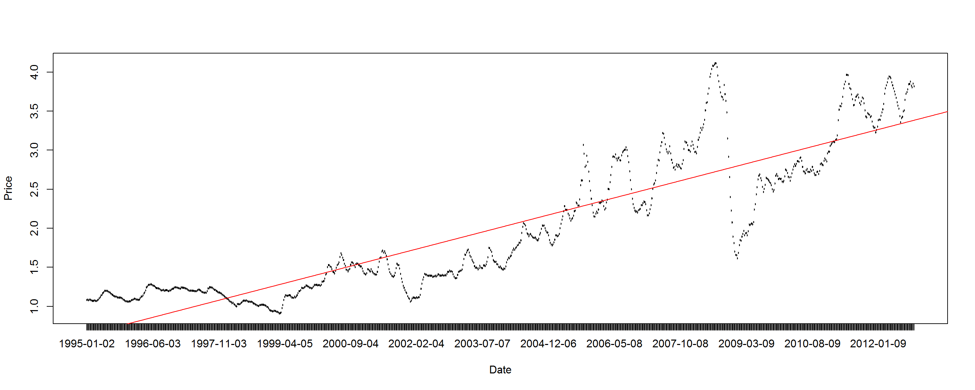
detrended.trajectory <- trend$residuals
plot(detrended.trajectory, type="l", main="detrended time series")
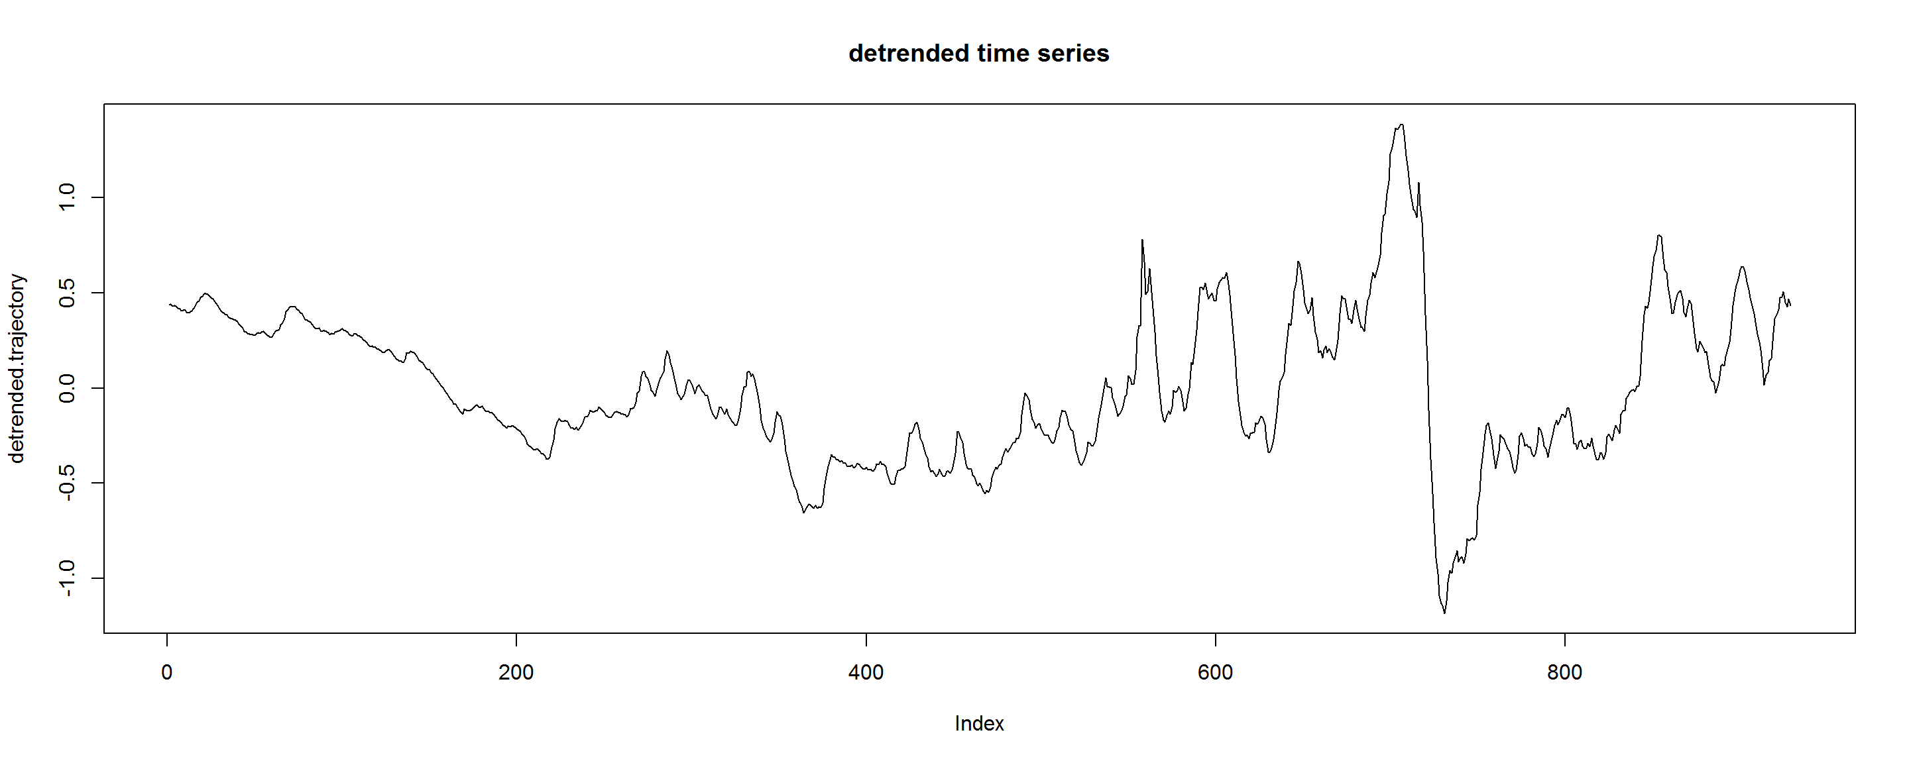
f.data <- GeneCycle::periodogram(detrended.trajectory)
harmonics <- 1:20
plot(f.data$freq[harmonics]*length(detrended.trajectory),
f.data$spec[harmonics]/sum(f.data$spec),
xlab="Harmonics (Hz)", ylab="Amplitute Density", type="h")
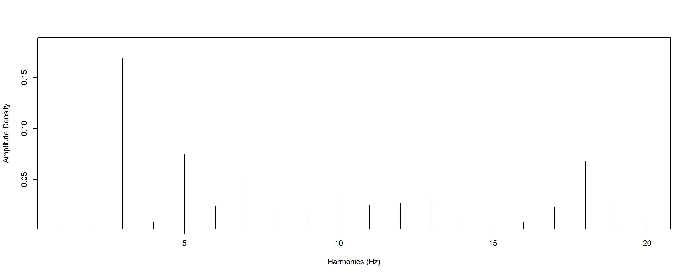
And we are able to see that the stronger signals are the 1Hz, 2Hz and 3Hz which makes some sense. The wages have a monthly or two-week cycle that reflects on the first harmonics (1 Hz here corresponds to 1 week cycle, 2 Hz means every 2 weeks, etc.).

